Shipment notification

The requirements to Materials & Equipment shipments
The following rules shall be complied with when planning shipments under supply agreements:
- In case of shipment of Materials & Equipment (hereinafter referred to as "ME") under several Supply Agreements (hereinafter referred to as "SA") with a single consignment note, the supplier shall send the Notices separately for each SA.
- In case of shipment of ME under several SA with a single consignment note, the supplier shall pack the goods under each agreement into a separate cargo package without placing goods under different SA into the same cargo package.
- In case of shipment of ME under the same SA on different but "close' dates, for example, on September 1, September 2, September 3, the supplier shall send the Notices separately for each of the shipment dates.
- Depending on the communication type for ME shipment, the "Consignee" shall be specified as per paragraph 5 of the Supply Agreement.
- Cargo packages in the packing shall be marking.

Filling out the shipment notification form

Filling out details and contacts

Template field Filling out guidelines Filling out sample
1. Shipment Choose the required type of the Shipment notification Railway (other)
Notification - Auto(General cargo)
- Truck (containers)
- Railway (covered rail car)
- Railway (other)
- Other

2а. Contract number | Specify (without space) the number of the supply agreement whereunder the shipment was made. | НН/96-2015/Н04-7DS
2b. Purchase order No. | To be filled out automatically after filling out the "Contract number" field | 4300001160
3. General Agreement | To be filled out automatically after filling out the "Contract number" field | НН/96-2015
4. Shipper | Specify the name, legal address, and contact phone number of the shipper | Erlau AG, Erlau 16, Aalen, Germany/ +7495 721-58-49
5а. Consignee | To be filled out when selecting the communication type "Direct" (8 section). In the dialog box, select the required option from the list. | Arkhangelsk transport branch PJSC “MMC “Norilsk Nickel”
5b. End consignee | Specify / choose from the list the Consignee and the End Consignee, depending on the type of communication (in accordance with section 5 of the Supply Agreement) | POLAR DIVISION OF PJSC MMC NORILSK NICKEL PESKh, TPTs No.1 WH. No.24
6. Shipment date | Specify the shipment date in the format "dd.mm.yyyy"  or select in the dialog box | 25.03.2014
7. Destination station/port/warehouse/location | Select from the list the port of transshipment, railway station or transit warehouse | Arkhangelsk  Lesosibirsk  Transit warehouse (Moscow)
8. Communication type | Select the communication type from the list | Mixed
9. Arrival to station/warehouse/port | Specify / select in the dialog boxes the period of the expected arrival at the destination railway station (under rail waybill), at the transshipment port or at the transit warehouse. Please note that the period shall be entered into two fields. If you know the exact date of arrival, please specify the same date in both fields. | 26.03.2014 — 27.03.2014

Filling out field "10. Vehicle Data"
Specify in the list the rail cars or vehicles on which the ME were shipped. The table shall have a separate line for each rail car / vehicle / platform / container, etc., even if one waybill covers several rail cars.

Template field | Filling out guidelines | Filling out sample
Vehicle type | Select vehicle type means from the list in the dialog box. | Auto
Vehicle number | Specify the full number of the rail car, gondola, platform or auto on which the shipment was made.  Attention! For the auto/truck it is required to specify the code of the vehicle registration region after a space. | Auto: T772KT 777  Rail car: 64451073
Seal number | Specify the seal impression number (Lock and seal device number), if available. If there are several numbers, specify all the numbers with a slash ("/"). | 0661224/0661235/0661254
Shipping document | Select from the list the type of the shipping document, specify the number and the date of the shipping document whereunder the shipment is made in the respective fields. The rail waybill number shall be specified with a prefix, without spaces. | Type: Waybill  Number: 26 or АП626300  Date: 25.03.2014
Carrier / rail car owner | In case of road transportation, specify the abbreviated name of the carrier's legal entity in accordance with the waybill. In case of railway transportation, specify the abbreviated name of the legal entity of the owner of the rail car / platform / container. | Rundz GmbH
Operator telephone | Specify the contact number of the operator. | +7 (495) 899-66-77

Filling out field "11. Batch cargo package data"

Specify in the list the cargo packages and the information about the shipped goods. The table shall have a separate line:
- for each ME/ME code for one cargo package (box, bundle, etc.)
- for each cargo package with the same ME/ME code with different weight and dimensions parameters. For example, when shipping bundles of pipes under the same ME code but with different weights and/or dimensions, each bundle type shall be entered into a separate line: bundles of 500 kg, bundles of 300 kg.
- for each cargo package with the same ME/ME code with different weight and dimensions parameters and different packing type, for example, for multi-piece equipment.
- for each cargo package with ME with different ME codes. Each such a package requires filling out a packing list, field14.
Also, depending on the type of the Notice selected, a different set of columns opens for filling out.
Template field | Filling out guidelines | Filling out sample
Set identifier | Specify the identifier of the set: if one unit with the same ME/under the same ME code has been shipped in several cargo packages (even on different shipping dates), please tick this box.  If this is the case, some fields become inactive, i.e. forbidden for filling out. | N Y
Package marking | Specify the cargo package marking.  This field shall be mandatorily filled out in the case of shipment:  - in the same cargo package there are several  goods with different ME codes (option  with a packing list),  - multi-piece equipment,  - containers in a mixed communication type  (each container shall be numbered  with numbers 1,2,3, etc.) | 26-1, 1/18…
Goods code  Position  Name | Select the ME code of the shipped goods in the dialog box in accordance with the specification to the supply agreement.  If several goods with different ME codes have been packed in the same cargo package, please select the "See packing list" option.  In case of shipment of multi-piece equipment under the same ME code and with different weight and dimensions parameters and type of packing, please select the ME code in each line in the dialog box  To be filled in the case of shipment goods for JSC "Kola MMC". In the dialog box select the option from the list, the appropriate quantity and time of delivery  To be filled in automatically after selecting the ME code. In case of shipment under a "packing list", specify in the field the detailed ME description (by name, for example, of the goods subgroups). | 361005  10(28.02.2018)  Блок графитированный,  Запорная арматура  (в случае упак листа)
ETSNG code | When transporting goods by rail, it is required to specify the ETSNG code (the classes of transport rates, also known as "Code 10-01") according to the rail waybill.  The ETSNG code is specified in the "Code" field of the "Cargo description" column of the waybill. For example, the column "Cargo description" specifies: "371051 Конструкции металлические, не поименованные в алфавите ": ETSNG code in this case shall be: 371051. | 371051
Packing type | Select the cargo package packing type from the list in the dialog box. In case of the shipment of goods in a container in direct mixed railway and water transportation (DMRWT), please select "container" from the list. | Crate  Bundle  Container
Quantity of goods | Specify the quantity of goods in one cargo package in units of measure according to the specification to the supply agreement. | 19
Unit | To be filled out automatically after filling out the "Goods code" field | Кг
Package gross Weight, kg | Specify the gross weight of one package in kilograms. In this case, if the weight of the package is specified with a fractional number, then the separator shall be a dot instead of a comma. In case of shipment of goods in one DMRWT container under several supply agreements ("container" packing type is selected), the weight of the container shall not be divided - each Notice shall specify the total weight of the container. Also, if a "Raft" is selected in field 10 "Vehicle type", the field becomes optional. | 1016.5
Package net Weight, kg | Specify the net weight of one package in kilograms. In this case, if the weight of the package is specified with a fractional number, then the separator shall be a dot instead of a comma. In case of shipment of goods in one DMRWT container under several supply agreements ("container" packing type is selected), the weight of the container shall not be divided - each Notice shall specify the total weight of the container. Also, if a "Raft" is selected in field 10 "Vehicle type", the field becomes optional. | 934.5
Number of packages | Specify the total number of the cargo packages (boxes, bundles, packets, containers, etc.) with this type of packing, the goods with the specified ME code (codes) and with the same weight and dimension parameters in the shipment. | 19
Total quantity of goods | Specify the total quantity of the goods for all cargo packages in units of measure according to the specification to the supply agreement.  Attention! By default this field is calculated automatically. | 361
Total gross weight, kg | Specify the total gross weight for all cargo packages in units of measure according to the specification to the supply agreement.  Attention! By default this field is calculated automatically. | 19313.5
Total net weight, kg | Specify the total net weight for all cargo packages in units of measure according to the specification to the supply agreement.  Attention! By default this field is calculated automatically. | 17755.5
Container number | Specify the full number of the container (with the prefix, without spaces), in which the shipment was made. | NMKU6194830
Seal number | Specify the seal impression number (Lock and seal device number), if available. If there are several numbers, specify all the numbers with a slash ("/"). | 0661224/0661235/0661254
Vehicle number | If the shipment has been performed by several means of transport (more than one means of transport specified in field 10 "Vehicle data"), the field "Vehicle number" is mandatory for filling out. Please specify (select from the list in the dialog box) the full number of the rail car, platform or auto, on which the shipment was made.  Attention! For the auto it is required to specify the code of the vehicle registration region after a space. | Auto: T772KT 777  Rail car: 64451073
Dimensions  Hazardous cargo  Note | If the dimensions of the cargo package are available, please specify them in this field in centimeters. This field is mandatory for filling out in case of shipment of oversized cargo (more than 10 meters by one of the measurements) and for shipment by road transport.  Specify a sign of a hazardous cargo: if a hazardous cargo has been shipped, please tick this box.  Specify additional information about the cargo packages with compulsory indication of a heavy piece (more than 10 tons).  For hazardous cargo, it is required to indicate the hazard class in accordance with GOST 19433-88. | 12800*1130*500  N Y  Heavy cargo,  hazard class 1.4

Filling out field "12. Entry Pass booking"
In case of the cargo road transportation, please specify in the list the autos and the drivers requiring an entrance pass to the port of transshipment.
Template field | Filling out guidelines | Filling out sample
Vehicle number | Automatic filling out (after filling out field 10)  Attention! For the auto it is required to specify the code of the vehicle registration region after a space. | T772KT 777
Trailer number | Specify the full license plate of the semi-trailer. If there is no trailer, put either a dash or "no". Attention! For a semi-trailer it is required to specify the code of the vehicle registration region after a space. | АЕ5517 29
Vehicle make; vehicle model; vehicle type; vehicle colour | Indicate the make, model, type (passenger / cargo), and the color of the vehicle in accordance with the waybill. | RENO Premium Cargo White
Full name of driver  Driver birth date  Driver contact data | Specify the driver's full name as in the passport.  Specify the driver's birth date  Specify the driver's phone No | Mr. Kogel  19.04.1991  +7(926) 333-33-33
Type and number of the document, the issuing authority and the date of issue | Specify the driver's ID type and No, the issuing authority and the date of issue. | Foreign passport KB 2263406, 19.12.2013г.

Filling out field "13. Contact person"
Specify the person responsible for the shipment and his/her contact details.
Template field | Filling out guidelines | Filling out sample
Full name | Specify the full name of the person responsible for the shipment. | Ходжаев Евгений Одилович
Telephone | Specify the contact phone number with the country / city access code. It is allowed to specify more than one contact phone. | +7 (495) 869-34-55
E-mail | Specify the contact e-mail address.  Attention! Please specify only one e-mail address | erlau@co.ru

Filling out field "14. Packing lists"
If goods under different ME codes are packed in the same cargo package (or a type of a cargo package), it is required to fill out a packing list for each such package (or a type of a cargo package).
Template field | Filling out guidelines | Filling out sample
Package marking | Specify / select in the dialog box the marking of the package for which the packing list is being generated. | 26-01, 1/18
Goods code | Specify the goods code packed in a cargo package. A separate line shall be provided for each ME code. | 361005
Net weight of goods, kg | Specify the weight of the goods with the specified ME code in the cargo package (it is desirable but not required to fill out this field).  Attention! The separator of the fractional part of the number shall be a dot instead of a comma. | 201.5
Quantity of goods | Specify the quantity of the goods in one cargo package in the measure units according to the specification to the supply agreement.  Attention! The separator of the fractional part of the number shall be a dot instead of a comma | 201.5
Unit | To be filled out automatically after filling out the "Goods code" field | Кг/т/шт/кмп
Note | Specify any additional information. | one barrel on a pallet with goods and  3 barrels of empty

Sending the shipping advice
A duly filled out Notice should be saved (click the "save" button) in order to allow the system to check for errors when filling out and then sent (click the "send" button).

Client service
If you have any questions concerning filling out the Notice form, please send them at e-mail and/or landline phone:

JSC «Kola MMC»
Oleg Salamov | (815-36) 7-95-54 | SalamovOS@kolagmk.ru
Tatyana Malyh | (815-36) 7-99-21 | MalyhTT@kolagmk.ru
Svetlana Melnik | (815-54) 3-58-53 | MelnikSP@kolagmk.ru
Petr Chechel | (815-36) 7-92-72 | ChechelPA@kolagmk.ru
Oksana Naumets | (815-54) 3-50-42 | NaumetsOA@kolagmk.ru
Svetlana Kuznecova | (815-54) 3-59-30 | KuznecovaSI@kolagmk.ru
Yurij Firsov | (815-36) 7-73-47 | FirsovYuS@kolagmk.ru
Arkhangelsk transport branch
Anastasiya Staritcyna | 8 (8182)67-10-87 | staritcynaan@nornik.ru
Viktoriya Pestova | 8 (8182)67-10-87 | pestovavo@nornik.ru
Tatyana Dokijchak | 8 (8182)67-13-98 | dokijchaktv@nornik.ru
Natalya Kulikova | 8 (8182)67-11-68 | kulikovanp@nornik.ru
Murmansk transport branch
Olga Ignakhina | (8152) 55-80-73 | IgnakhinaOA@nornik.ru
Irina Rasyuk | (8152) 55-80-74 | RasyukIA@nornik.ru
OJSC «Krasnoyarsk River Port»
Nadezhda Kazharova | 8(391) 252-27-20 | zsk2@krasrp.ru
Evgeniya Lobanova | 8(391) 252-27-20 | zsk2@krasrp.ru
Olga Zhilina | 8(391) 252-26-30 | ZhilinOG@nornik.ru
Tatyana Semenova | 8(391) 252-26-21 | semenova@krasrp.ru
OJSC «Lesosibirsk Port»
Oksana Bagrova | 8(39145)6-21-45, add.1099 | bagrova_oa@lrport.ru
Irina Lavilina | 8(39145)6-21-45, add.1099 | lavilina_ia@lrport.ru
Larisa Simonova | 8(39145)6-21-45, add. 1137 | simonova_lv@lrport.ru

In case of technical errors, please send your inquiries at helpdesk@nornik.ru.
In case of impossibility to send an e-mail, please call:
• In Moscow: +7 (495) 787-00-45
• In the Russian Federation: +7 (800) 700-59-11(toll free federal number)
When applying to the Client service please specify that the problem relates to the Suppliers Notice Portal and leave your contacts for reply

Samples of filling out the Notices
- Options for filling out fields 1-10

- shipment by auto
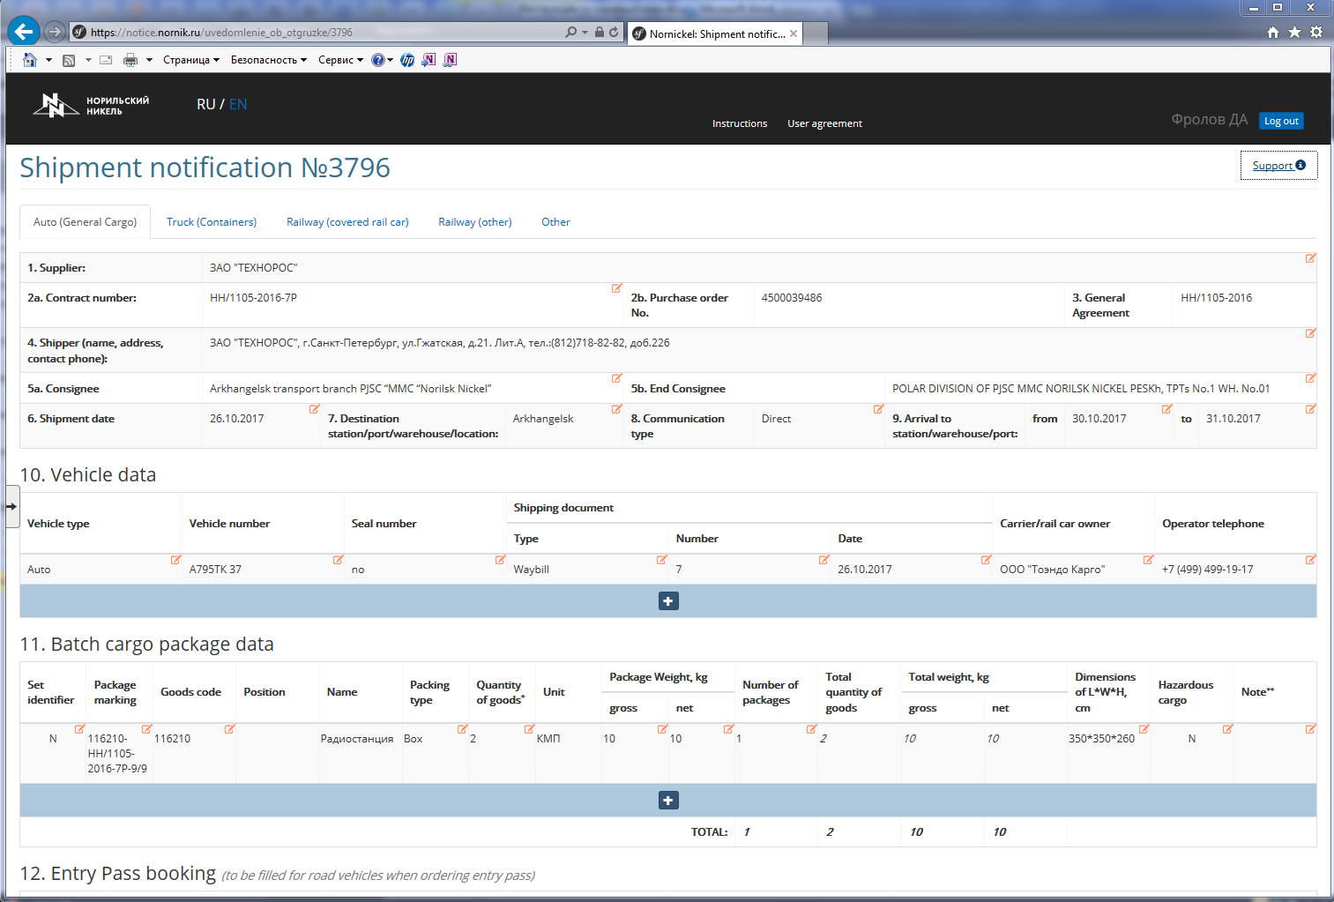

- shipment by through railway service

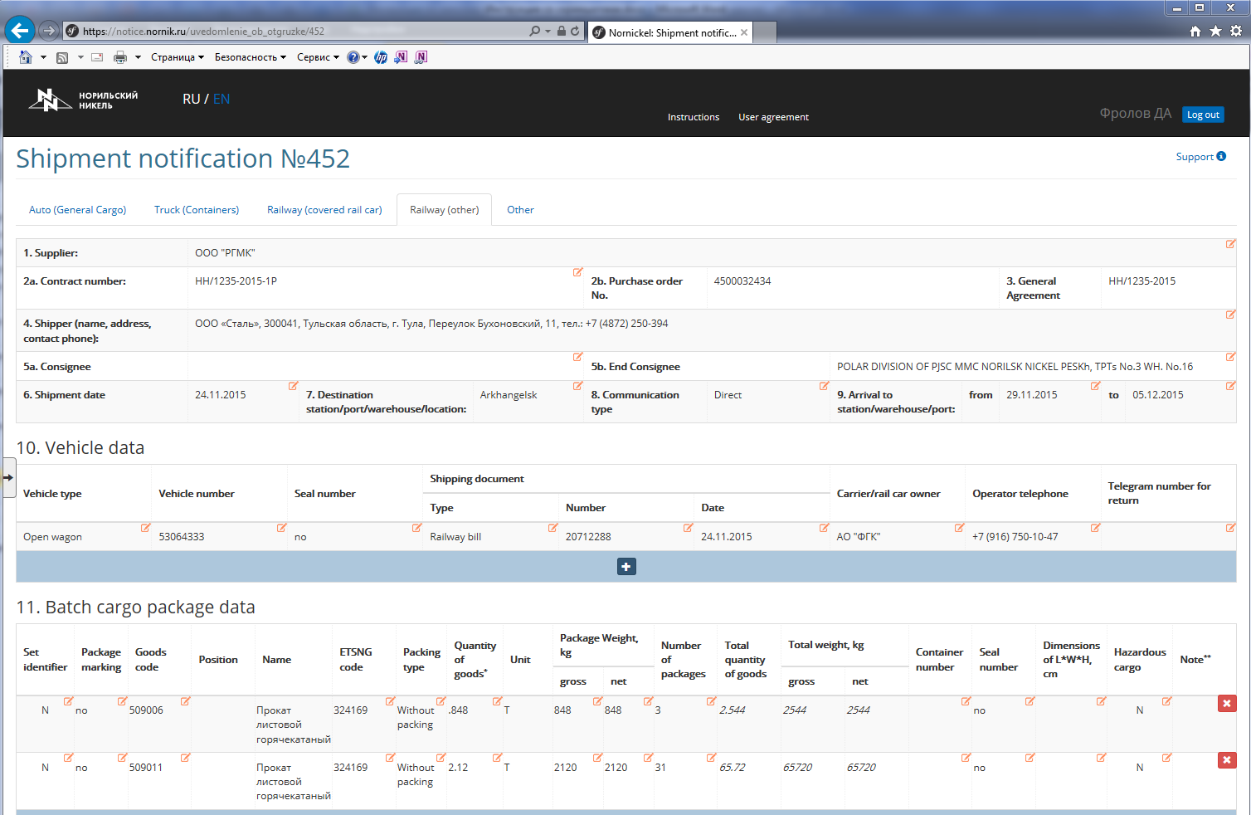

- shipment by direct mixed railway and water transportation (in open wagonand containers)

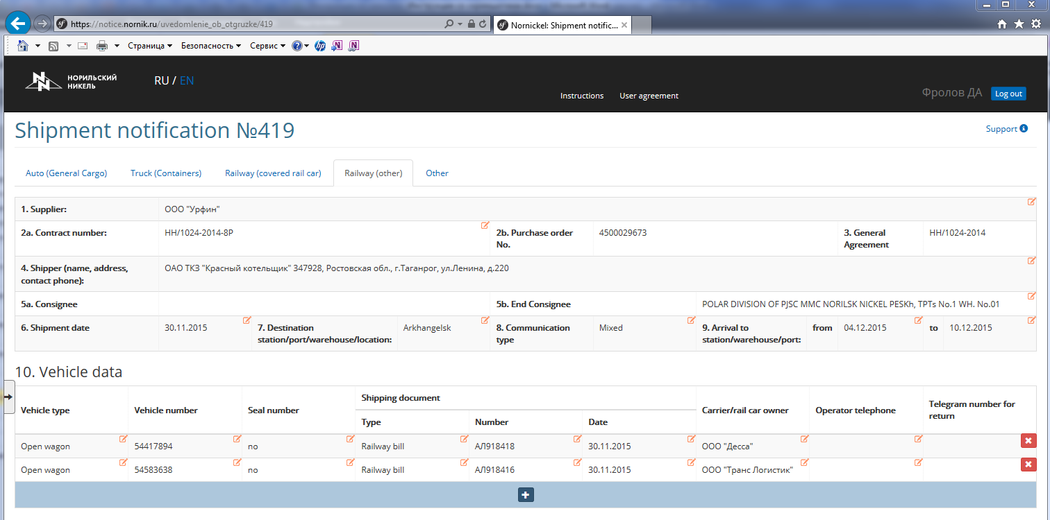
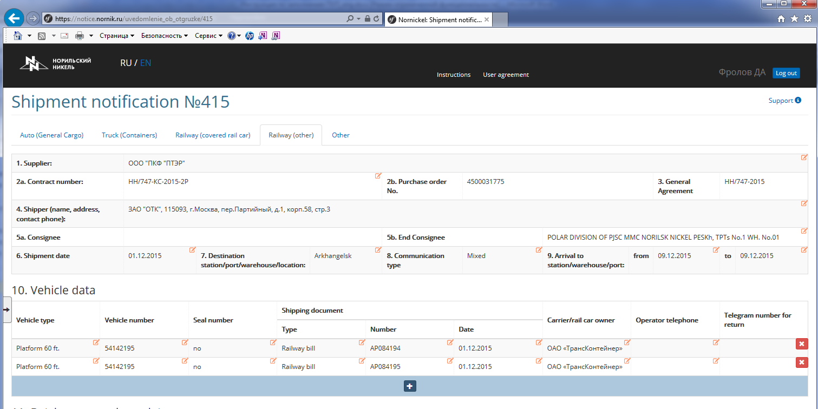

- shipment by air

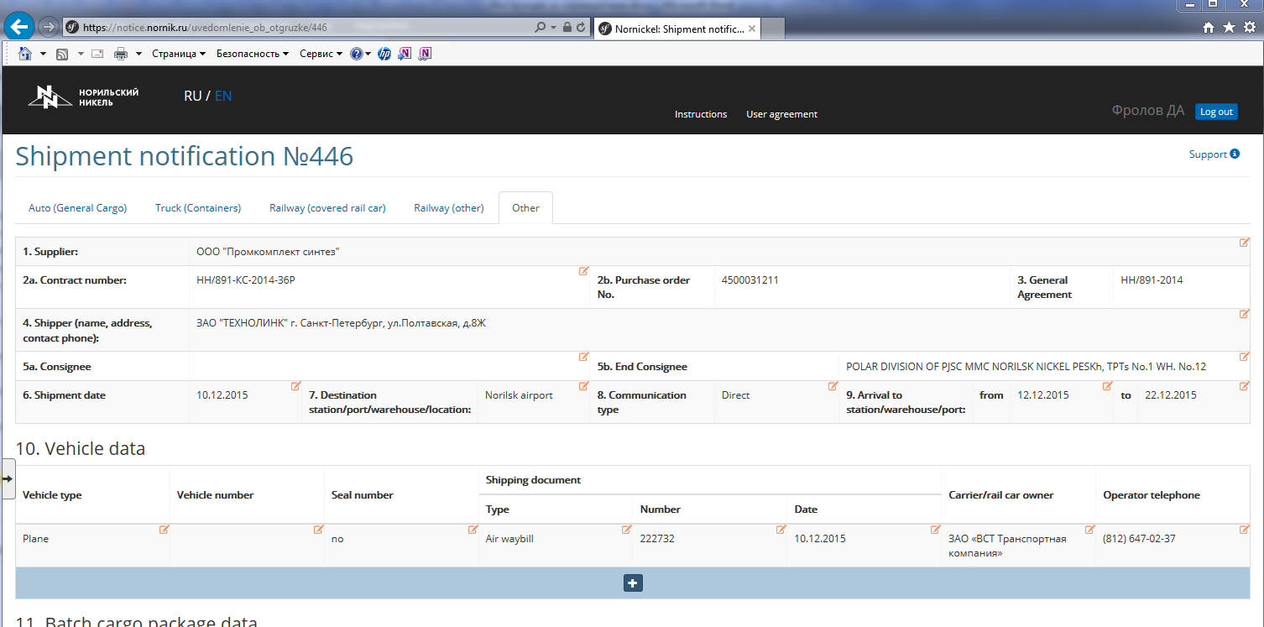

2. Options for filling out field 11 "Batch cargo package data"
- for each cargo package with the same ME/ME code (box, bundle, etc.)

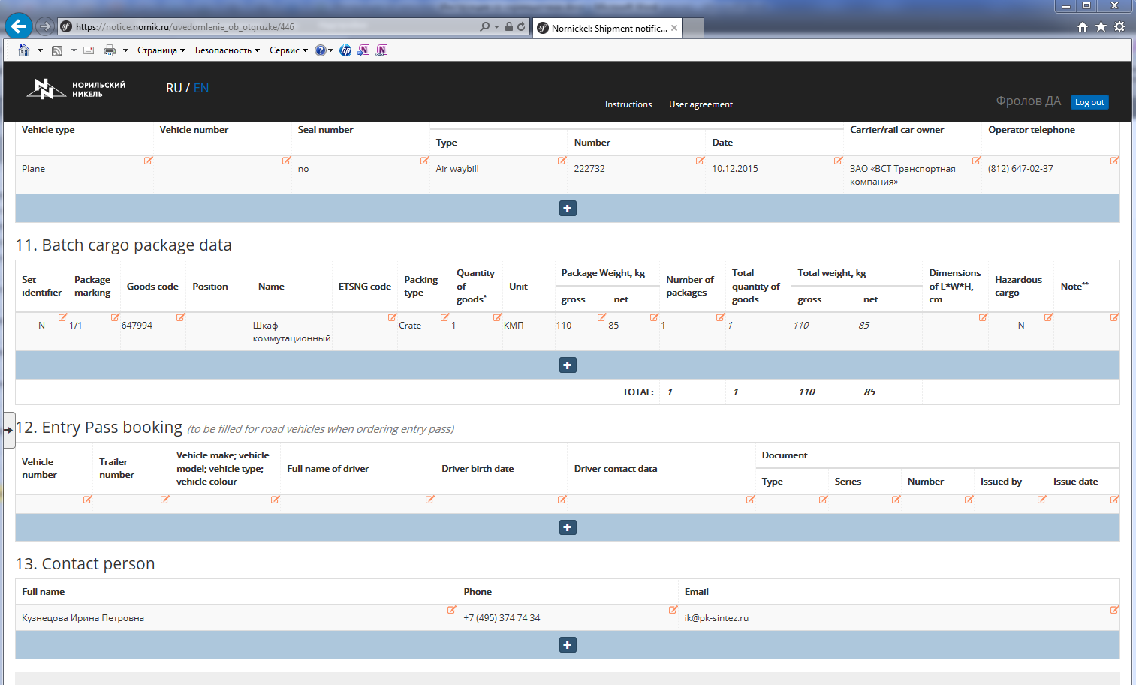

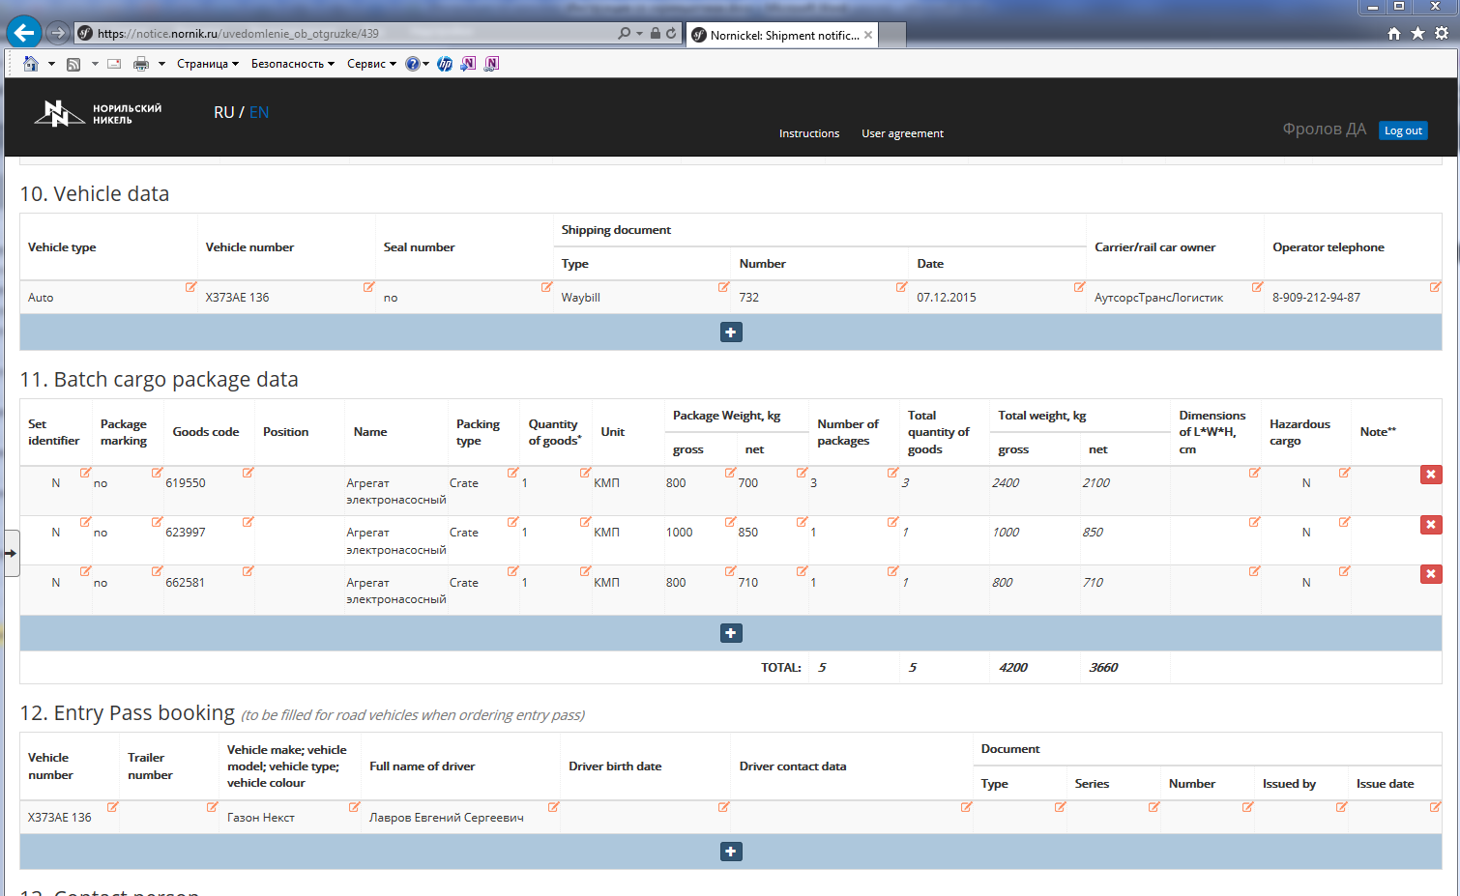
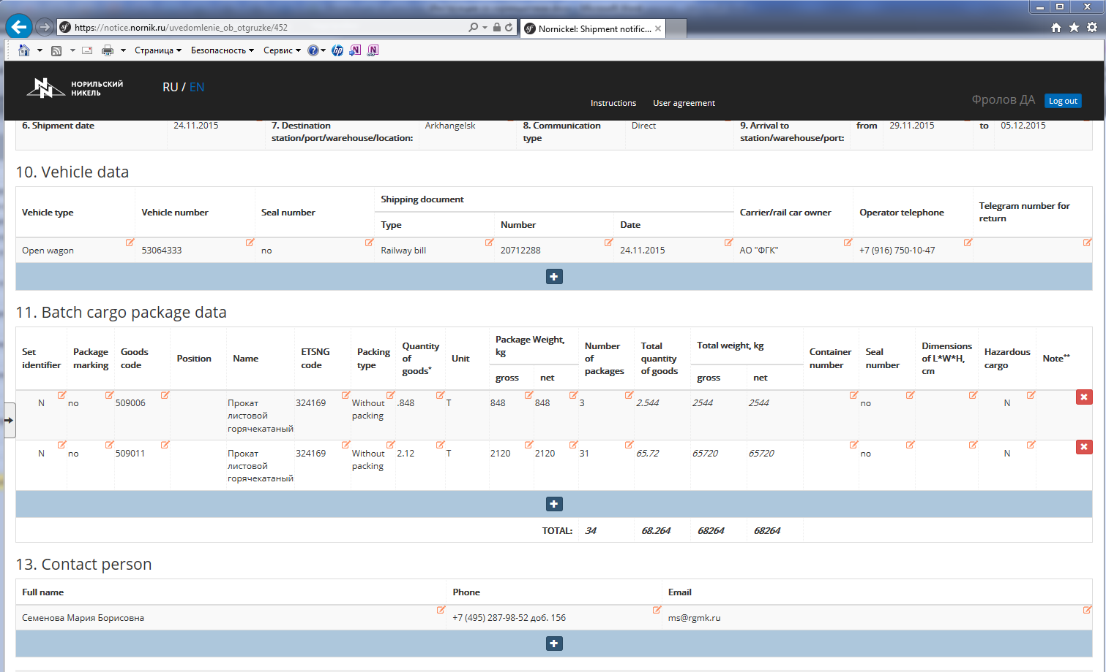

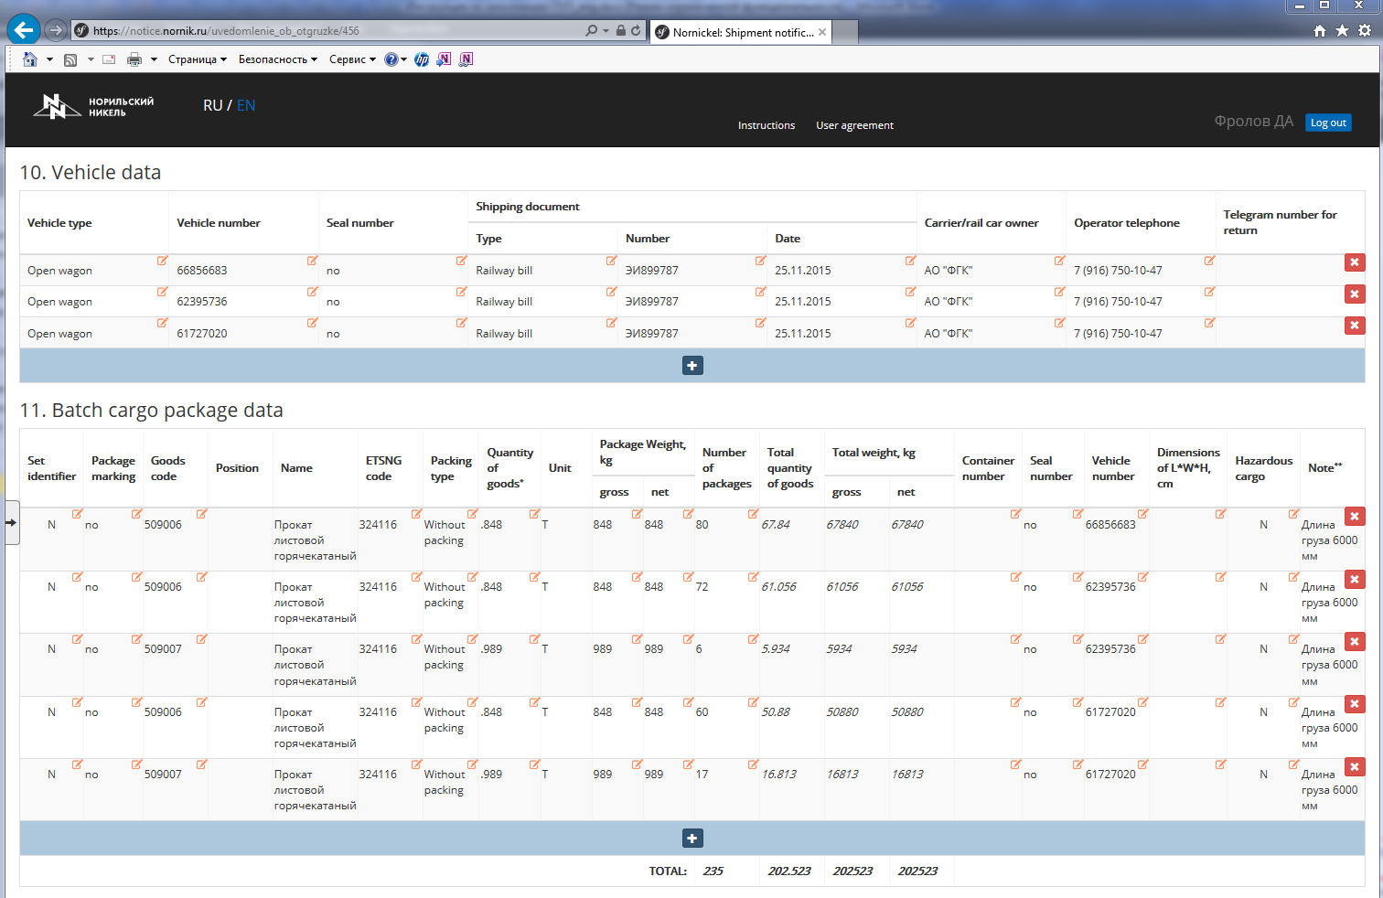

- for each cargo package with the same ME/ME code with different weight and dimensions parameters
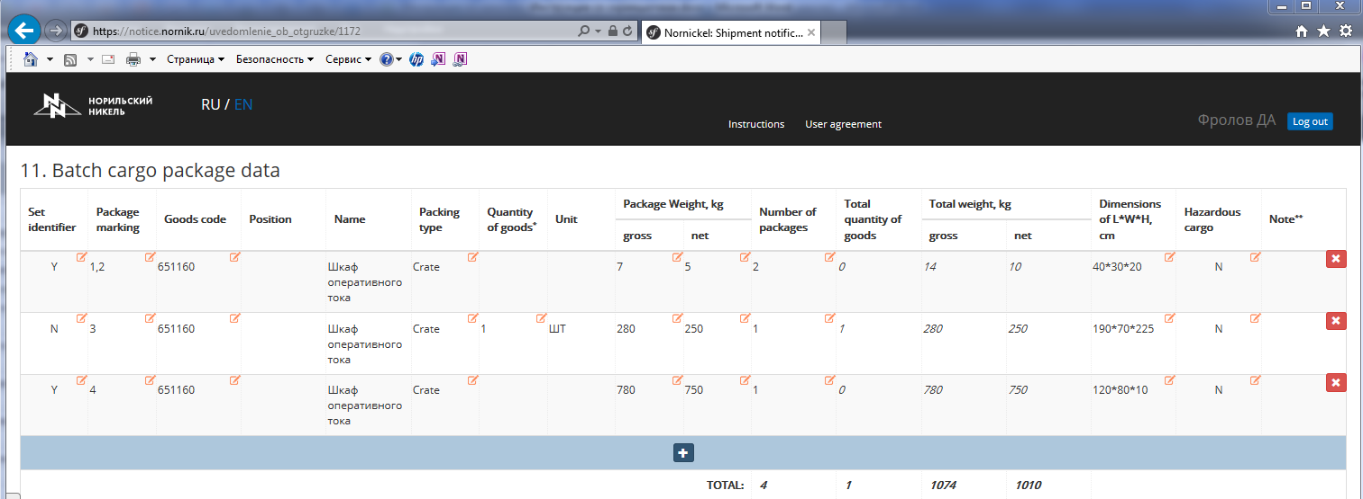

- for each cargo package with the same ME/ME code with different weight and dimensions parameters and/or different type of packing (multi-piece equipment)

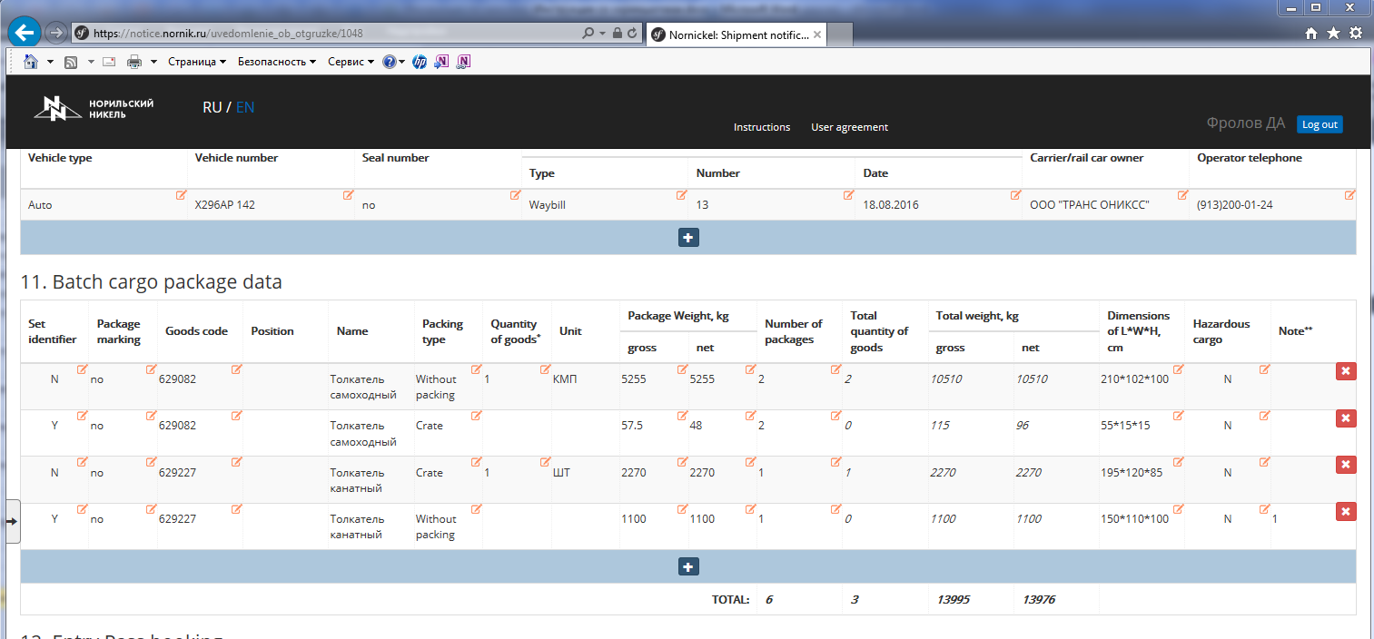

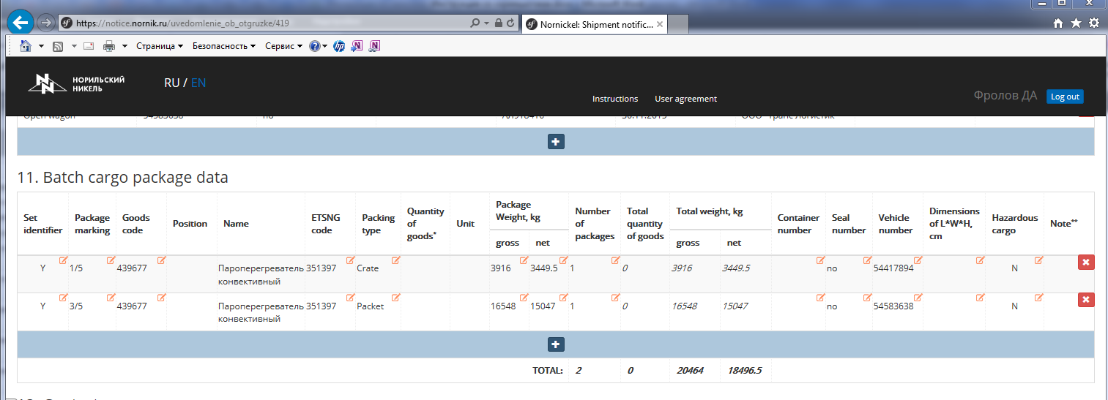

- for each cargo package with ME under different ME codes with filling out field 14 "Packing Lists".

